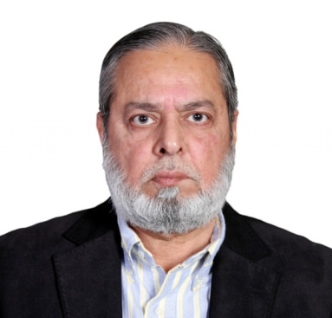BRIEF PROFILE

Mian Muhammad Jamil

###### PERSONAL INFORMATION

**Name**  : Mian Muhammad Jamil

**Father’s Name** : Haji Ahmad Hassan

**Date of Birth** : April 2, 1948

**NIC No.** : 36302-0443809-3

**Educational Qualification** : B.Sc Textile Engineering with Specialization in Textile Weaving from National College of Textile Engineering, Faisalabad – 1968 - 1971

**Trade/Business** : Industrialist

**Office Address** : Allawasaya Square, Mumtazabad Industrial

Area, Vehari Road, Multan, Pakistan.

**Telephone** : 061-4233624-26

**Fax** : 061-6525202

**E-mail** : jamil@allawasaya.com

**Website**  : [www.allawasaya.com](http://www.allawasaya.com)

**Residence** **Address**  : 37-A, Tipu Sultan Road, Multan Cantt., Pakistan.

**Business Interests** : Cotton, Textiles & Trading

###### DIRECTOR MARKETING & SALES

* Allawasaya Textile and Finishing Mills Ltd. From: 02-06-2018 still continuing

###### CHIEF EXECUTIVE OFFICER

* Allawasaya Spinning Mills (Pvt.) Ltd. From: 07-05-2024 still continuing

###### CHAIRMAN

* Allawasaya Spinning Mills (Pvt.) Ltd. From : 14-10-2004 to 06-05-2024
* Allawasaya Textile and Finishing Mills Ltd. From: 03-08-1994 to 02-06-2018

###### DIRECTOR

* Allawasaya Textile and Finishing Mills Ltd. From: 31-12-1981 to 03-08-1994

###### OTHER POSITIONS HELD

* **Member**  Multan Garrison Mess

Managing Committee of the Federation of Pakistan Chambers of Commerce & Industry, 1998 to 2000 (FPCCI)

* **President** Multan Chamber of Commerce & Industry, 1992-1993 (MCCI)

###### EXPERIENCE

More than 45 Years experience in successfully managing the Industrial Companies of his Group as detailed above and also as President of Trade Body like the Multan Chamber of Commerce & Industry and Member Managing Committee of the Federation of Pakistan Chambers of Commerce and Industry.

Having vast experience in managing technical side of spinning as well as in sales & marketing.